our
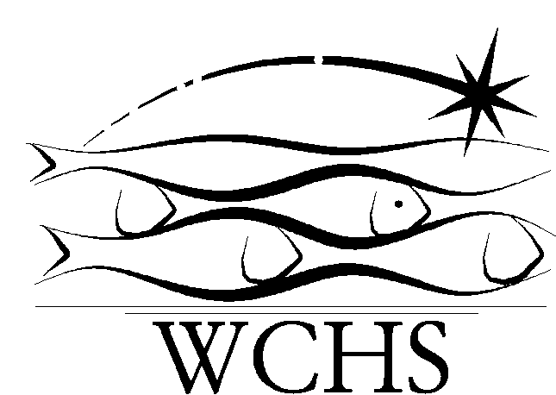
WARNBRO COMMUNITY HIGH SCHOOL

ASSESSMENT PROGRAM
Year 12 ATAR CHEMISTRY

Teacher: Dr Barnier Melissa.Barnier@education.wa.edu.au

Note: Scheduling and details for individual assessment items may be subject to minor changes.

 | Due dates | Assessment item/task | Assessment method | % weighting
TERM 1 | Wk 4  Wk 5  Wk 8  Wk 9 | Task 1 – Chemical equilibrium systems  Task 2 – Climate change, ocean chemistry and Le Chatelier’s principle  Task 3 – Investigation: Volumetric analysis of a vinegar solution  Task 4 – Acids/bases and volumetric analysis | Test  Extended Response  Science Inquiry  Test | 3  5  5  4
TERM 2 | Wk 13  Wk 13  Wk 15  Wk 19  Wk 20 | Task 5 – Redox reactions and electrochemical cells  Task 6 – Practical test: Validation of experiments conducted, including data analysis, inquiry skills  Task 7 - Semester 1 examination  Task 8 – Investigation: Analysis of aspirin tablets  Task 9 – Classes of organic compounds | Test  Science Inquiry  Examination  Science Inquiry  Test | 3  5  20  5  3
TERM 3 | Wk 24  Wk 27  Wk 28  Wk 28  Wk 30 | Task 10 – Polymers and molecules for living  Task 11 – Chemical synthesis, molecular manufacturing and green chemistry  Task 12 – Chemical Synthesis: Haber process, contact process and other applications  Task 13 – Practical test: Validation of experiments conducted, including data analysis, inquiry skills  Task 14 – Semester 2 examination | Test  Test  Extended Response  Science Inquiry  Examination | 3  4  5  5  30
Total |  |  |  | 100

Note to parents:

Please acknowledge that you have reviewed this Assessment Program by signing below.

________________________________ Tick box for extra copy to keep at home
Parent’s signature

